**Description**

As a user I should be able to type any keyword in textbox and zipcode so that I can find some activity .

As a user I should be able to see suggestions on the page so that I can get some idea on what to search.

------------------------------------------------------------------------------------------------------------------------------------------

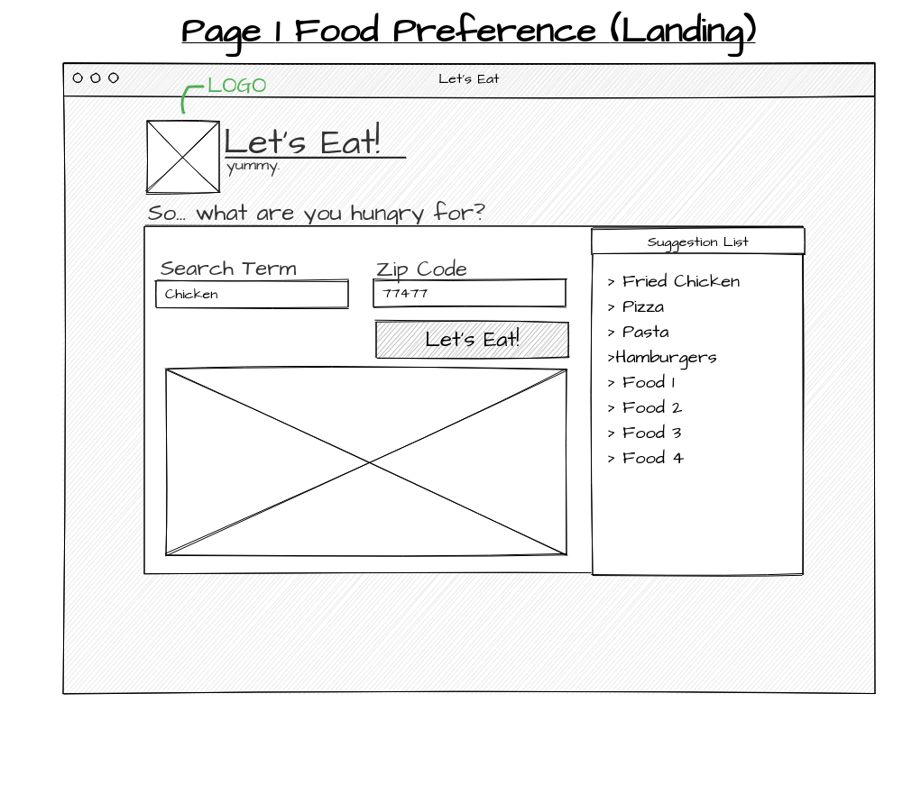

**Acceptance criteria**

* Search keyword is not empty.
* Zipcode is not empty and is in right format
* Search button is always displayed and I can either click or press Enter key
* Suggestion list is always displayed.